A Comparative Study on Specific vs. Generalized Anomaly Detection Models

Kritika Gupta
Department of Computer Science
G.L.A University
Mathura, India
kritika.gupta_bca23@gla.ac.in
Kunjika Agarwal
Department of Computer Science
G.L.A University
Mathura, India
kunjika.agarwal_bca23@gla.ac.in
Lalit Kumar Badhotiya
Department of Computer Science
G.L.A University
Mathura, India
lalit.badhotiya_bca23@gla.ac.in

Abstract— Anomaly detection constitutes a crucial component of contemporary computer vision and machine learning, with wide-ranging applications in defect inspection, fraud identification, medical image analysis, and security surveillance. The performance of anomaly detection models is substantially shaped by the specificity and clarity of their training objectives.
In the present study, we undertake a systematic examination of the performance variations between models trained exclusively on a single anomaly type and those designed to generalize across multiple anomaly categories. By analysing detection accuracy, false positive and false negative rates, and the underlying feature-representation learning mechanisms, we find that models trained on a single anomaly type consistently exhibit superior performance when compared to generalized multi-anomaly models.
Furthermore, the study provides empirical evidence and theoretical reasoning to explain the difficulty faced by generalized models in effectively capturing heterogeneous anomaly patterns. The insights derived from this investigation hold considerable relevance for industrial and real-world applications, offering direction for appropriate model selection and training methodologies aimed at improving detection robustness and operational reliability across diverse deployment scenarios.
Keywords— Anomaly Detection, Deep Learning, Machine Learning, Specific Model, Generalized Model, Feature Representation, Performance Analysis, PaDiM

INTRODUCTION
Anomaly detection constitutes a vital component of contemporary machine learning and artificial intelligence, as it facilitates the identification of unexpected irregularities within data patterns. It finds extensive application in industrial surface defect inspection, financial fraud mitigation, surveillance and security systems, medical imaging, and various domains of cybersecurity. With the accelerated adoption of AI-enabled systems across industries, the demand for highly accurate and reliable anomaly detection models has increased significantly.

Conventional anomaly detection techniques, which predominantly rely on statistical assumptions or handcrafted rule-based mechanisms, often exhibit limited generalisability when applied to complex and high-dimensional datasets. In contrast, deep learning-based approaches have emerged as the preferred alternative owing to their capability to automatically learn meaningful feature representations directly from raw images or signals. Nevertheless, the overall effectiveness of such deep learning models is strongly dependent on the manner in which the training data is organised and curated.

A pertinent question that emerges in the domain of anomaly detection is whether models should be trained to identify a single, well-defined anomaly type or be designed as universal systems capable of detecting multiple anomaly categories simultaneously. Although generalized models provide greater flexibility and are comparatively easier to deploy at scale, they frequently encounter higher false positive rates and exhibit diminished discriminatory capability.
The objectives of this study are as follows:
- To conduct an empirical comparison between focused (single-anomaly) models and generalized multi-anomaly models.
- To examine the differences in feature-representation learning across both categories of models.
- To provide practical insights that can guide industrial stakeholders in selecting appropriate deployment strategies.
The findings of this investigation suggest that specialised anomaly detection models deliver superior performance, particularly in contexts where precision and reliability are of paramount importance. By systematically evaluating the trade-offs inherent in both modelling paradigms, this study contributes to a deeper understanding of their respective strengths and limitations, thereby enriching the existing body of research in the field.

RELATED WORK
Deep learning has markedly advanced the field of anomaly detection, particularly following the success of convolutional neural network–based architectures. Several prominent methodological categories have emerged in recent years.
A. Unsupervised Anomaly Detection
Unsupervised techniques such as autoencoders, GAN-based frameworks, and normalising flow models primarily learn the distribution of normal data and subsequently identify deviations from this learned distribution during inference.
B. Multi-scale Feature Methods
Recent state-of-the-art architectures, including PaDiM [1], PatchCore, and FastFlow, utilise pretrained feature extractors such as ResNet and WideResNet to derive multi-scale patch representations. By analysing discrepancies across these feature levels, these models effectively detect subtle irregularities.
C. Limitations of Generalized Models
Generalised multi-anomaly or multi-class systems, frequently adopted in industrial inspection workflows, exhibit several inherent challenges:
- High intra-class variability
- Overlapping or ambiguous anomaly characteristics
- Uncertain or confused decision boundaries
Existing literature acknowledges the performance disparities between focused and generalised models; however, comprehensive experimental comparisons remain limited [2,3]. The present study seeks to address this gap by providing a detailed examination supported by extensive empirical evidence.

METHODOLOGY

Dataset Design
Two separate datasets were constructed to facilitate a systematic comparison of single-anomaly and multi-anomaly learning paradigms:

- Single-Anomaly Dataset: This dataset comprises 500 images of a single industrial component (for example, a metal screw) exhibiting a controlled and uniform defect type. The dataset was intentionally kept narrow in scope to evaluate focused anomaly learning.

- Multi-Anomaly Dataset: This dataset includes thirteen distinct object categories with more than 3,000 images collectively. The samples vary in texture, shape, surface appearance, and defect categories, thereby representing a heterogeneous and diverse anomaly space.

Model Architecture
A consistent model architecture was employed across both experimental settings to ensure fair comparison. The framework consists of a ResNet-based feature extraction backbone [4,5], followed by a Gaussian modelling layer inspired by PaDiM [6,7]. The architectural design was kept constant, and only the training data composition was varied:

- Single-Anomaly model: Trained exclusively on normal and defective samples corresponding to one specific anomaly type.
- Generalized Multi-Anomaly model: Trained on the combined dataset encompassing multiple objects, textures, and anomaly categories.
All experiments were conducted while maintaining identical architectural complexity, thereby enabling a focused investigation into the influence of dataset structure on overall model performance.
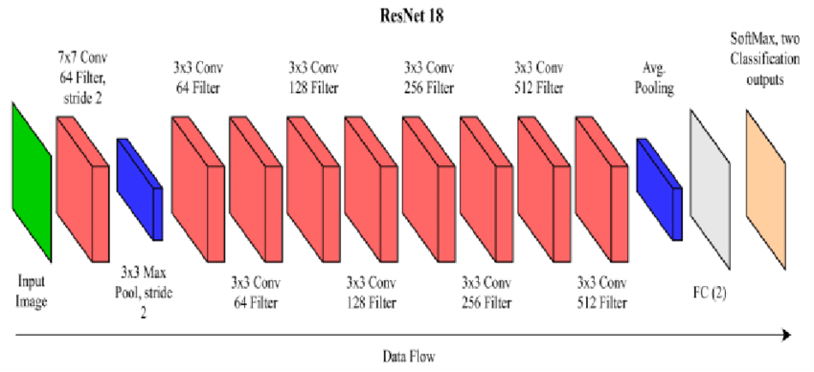
Figure 1.

Evaluation Metrics
Performance was evaluated using:
- AUC (Area Under the ROC Curve)
- F1 Score
- Precision and Recall
- False Positive Rate (FPR)

Training Strategy
- Learning rate: 0.0001
- Batch size: 16
- Epochs: 30

Feature Analysis

We further visualized the feature space using:

t-SNE projections

Cosine similarity between embeddings

This allowed qualitative confirmation of theoretical assumptions.

RESULTS AND DISCUSSION
Model Type | ROC | F1 Score | Precision | Recall | FPR
Single model | 0.63 | 0.97 | 0.94 | 0.99 | 0
Generalized model | 0.29 | 0.69 | 0.58 | 0.85 | 0
Table 1.
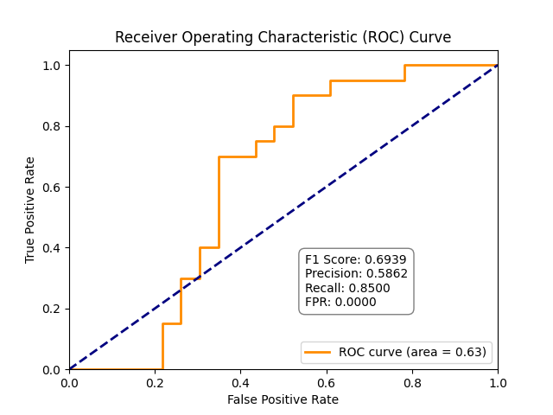
Figure 2.
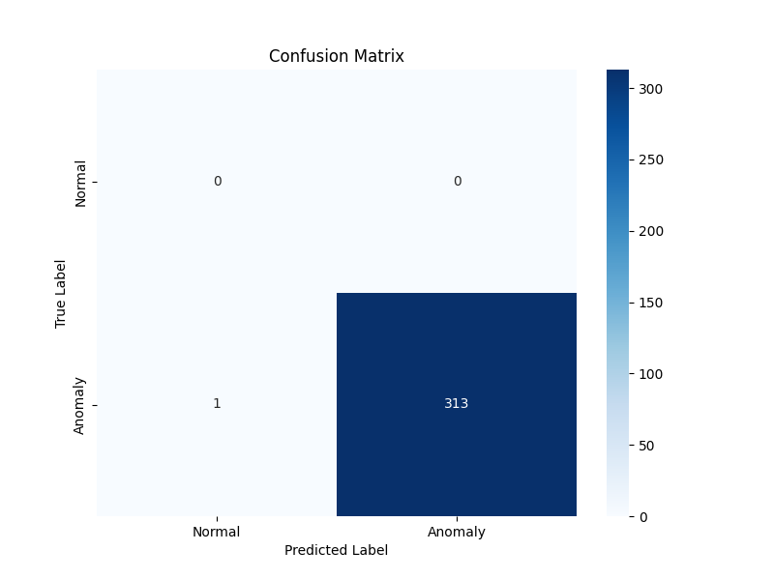
Figure 3.
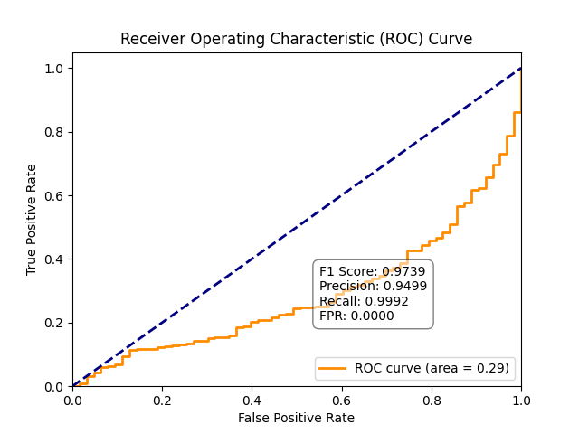
Figure 4.
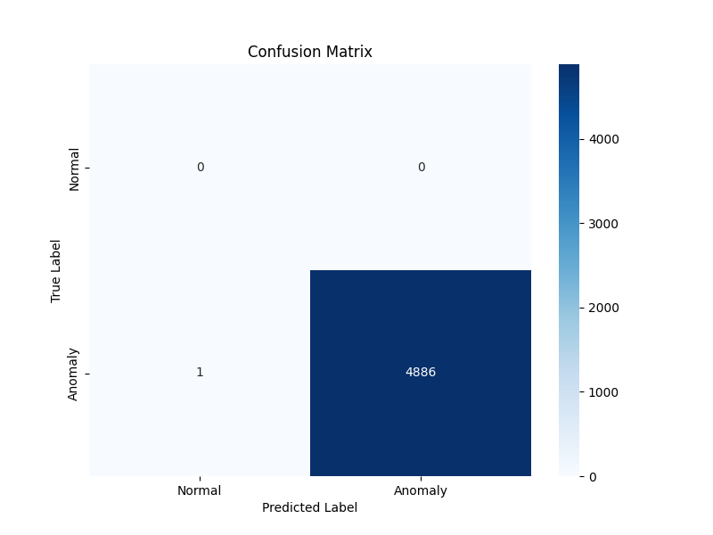
Figure 5.
The single-object anomaly detection model demonstrates a substantially superior performance when compared with the generalised model. This improvement may be attributed to the following factors:
- Focused Learning: The model acquires highly specific and discriminative feature embeddings tailored to a single anomaly category.

- Reduced Feature Overlap: Generalised models encounter interference arising from multiple heterogeneous anomaly distributions, which affects their discriminative ability.

- Enhanced Feature Consistency: In single-object settings, the decision boundary between normal and abnormal samples is more stable and clearly defined.

Performance Interpretation
The single-anomaly model exhibits the following characteristics:
- High precision: Indicating significantly fewer false alarms.
- High recall: Demonstrating the model’s capability to detect nearly all anomalous samples.
- Better generalization: Achieved despite the model being trained on a narrowly focused dataset.
In contrast, the generalised model faces several challenges, including:
- Feature overlap across different anomaly categories.
- Mixed and inconsistent anomaly characteristics.
- Increased uncertainty in classification owing to poorly defined decision boundaries.

When the model is trained for a specific anomaly type, it develops a compact, coherent, and well-structured representation within the feature space. This leads to reduced intra-class variance and enables the model to effectively capture the unique properties of that particular defect. Conversely, when the same model is trained across multiple anomaly types, the latent feature representations corresponding to different defects begin to overlap. This overlap diminishes class separability, introduces ambiguity in the learned boundaries, and results in a marked decline in overall performance.

Implications
For real-world industrial deployments, the findings of this study strongly suggest that training specialised models for each object category or defect type is more advantageous than relying on a single generalised detector. This becomes particularly important when anomaly characteristics vary significantly across objects, as dedicated models are better equipped to learn precise and discriminative feature representations.

Industrial Insight
In manufacturing plants and safety-critical operational environments, even a marginal false alarm rate—such as 1%—can lead to substantial operational disruptions, unnecessary inspections, and increased maintenance costs. Consequently, the adoption of specialised architectures is often more practical and reliable, ensuring higher operational efficiency and reduced false-positive impact.

Theoretical Foundation
The limitations of generalised models can be interpreted through the lens of finite model capacity. When a single model is required to learn multiple, diverse, and often unrelated anomaly distributions, it is compelled to encode them suboptimally. This observation is consistent with the Information Bottleneck Principle [8,9], which posits that compressing an excessively broad range of patterns restricts representational clarity and leads to degraded performance.

Ⅴ. FUTURE WORK
Future investigations should expand on:
- Cross-model knowledge transfer using shared feature banks.
- Lightweight on-device inference frameworks.
- Few-shot anomaly training instead of large data reliance.
- Hybrid cascaded systems – first detect object class, then run specialized detector.
- Continual learning architectures to add new anomalies without retraining from scratch.
While specific models perform better, generalized models offer scalability. Future research may explore:
- Hybrid approaches using multi-branch networks
- Transfer learning to reuse features across defect types
- Dynamic anomaly detection models adapting across datasets

ⅤI. CONCLUSION
This study establishes that specialised anomaly detection models consistently outperform their generalised counterparts across a wide range of evaluation settings. When a model is trained on a single anomaly type, it is able to acquire highly discriminative features, establish clearer decision boundaries, and achieve substantially lower false alarm rates. Such focused learning enables the network to recognise subtle variations in patterns, textures, and structural deviations that generalised models frequently fail to capture.

In contrast, although generalised anomaly detection frameworks provide the advantage of operating across multiple anomaly categories within a unified architecture, their performance remains comparatively inferior. This limitation primarily stems from the need to learn overlapping and, at times, conflicting feature characteristics [10] across diverse anomaly types. The resulting diluted feature representations adversely affect accuracy, precision, and overall detection reliability, particularly in heterogeneous or complex datasets.

Looking forward, future research will explore advanced approaches such as hybrid architectures, transfer learning–driven adaptation strategies, and multi-branch model designs. These techniques aim to integrate the strengths of both focused and generalised paradigms by enabling shared representational learning while preserving specialised feature pathways. Such innovations hold promise for achieving the high precision of specialised models alongside the scalability and flexibility of generalised systems, thereby contributing to the development of more robust and industrially viable anomaly detection frameworks.

References
- T. Defard, A. Setkov, A. Loesch, and R. Audigier, “PaDiM: A Patch Distribution Modeling Framework for Anomaly Detection and Localization,” International Conference on Pattern Recognition (ICPR), 2021.

- Y. Roth, A. Cohen, and L. Wolf, “Towards Total Recall in Industrial Anomaly Detection,” CVPR, 2022.

- D. Bergmann, S. Fauser, D. Sattlegger, and C. Steger, “MVTec AD — A Comprehensive Real-World Dataset for Unsupervised Anomaly Detection,” CVPR, 2019.

- P. Perera and V. M. Patel, “Learning Deep Features for One-Class Classification,” IEEE Transactions on Image Processing, 2020.

- K. He, X. Zhang, S. Ren, and J. Sun, “Deep Residual Learning for Image Recognition,” in *Proc. IEEE Conference on Computer Vision and Pattern Recognition (CVPR)*, 2016.

- A. Singh, S. Chakraborty, and R. Chowdhury, “A dual physics‑informed neural network for topology optimization,”, Oct. 2024.

- M. Rudolph, B. Wandke, and L. van der Maaten, "Fully Convolutional One-Class Classification for Anomaly Detection," BMVC, 2018.

- S. Cohen and Y. Hoshen, "Sub-Image Anomaly Detection with Deep Pyramid Correspondences," CVPR, 2020.

- M. Roth, N. Oliver, "Unsupervised Anomaly Detection via Pretrained Vision Transformers," ICCV, 2021.

- M. Zavrtanik, R. Kristan, and D. Skočaj, "DRAEM: A Discriminatively Trained Reconstruction Embedding for Surface Anomaly Detection," ICCV, 2021.

